OPTIMIZATION FLIGHT BOOKING THROUGH MACHINE LEARNING
PRICE PREDICTION

INTRODUCTION:
Flight booking can be a complex and time-consuming process, particularly when trying to find the best deals and optimal times to travel. However, advancements in machine learning technology have made it possible to streamline this process by predicting flight prices and optimizing booking decisions.
Machine learning algorithms can analyze vast amounts of historical flight data, including ticket prices, booking times, and availability, to identify patterns and trends that can inform pricing predictions. By training models on this data, they can learn to accurately forecast the likelihood of price changes and help travelers make informed booking decisions.
Optimization of flight booking through machine learning price prediction can provide several benefits, including improved cost savings and time management. By predicting price changes, travelers can book flights at optimal times, allowing them to save money and avoid paying higher fares. Additionally, machine learning algorithms can take into account factors such as travel preferences and scheduling constraints to provide personalized recommendations for the best flights to book.
Overall, machine learning-based price prediction and optimization can revolutionize the way travelers book flights, making the process more efficient and cost-effective.

  - Overview:

Optimizing flight booking through machine learning price prediction involves using machine learning algorithms to predict the price of flights in the future, which can help travelers find the best time to book their flights for the lowest possible price.

The process typically involves collecting and analyzing historical flight data to identify patterns and trends, as well as incorporating various external factors such as fuel prices, weather conditions, and economic indicators that can affect flight prices. The machine learning algorithms then use this data to make predictions about future flight prices, taking into account factors such as time of year, day of the week, and even the specific airline and route.

The predictions generated by the machine learning models can be used by travel companies and websites to offer personalized recommendations to customers based on their preferences and budget, and to optimize their pricing strategies to maximize revenue. Travelers can also use these predictions to make informed decisions about when to book their flights, potentially saving them money in the process.

Overall, optimization of flight booking through machine learning price prediction is an emerging area of research and development in the travel industry, with the potential to offer significant benefits to both travel companies and consumers alike.

1.2 PURPOSE:

The purpose of using machine learning for flight booking and price prediction is to provide travelers with more accurate and cost-effective travel options. By analyzing historical data, machine learning algorithms can make predictions about the price of a flight based on various factors such as the time of year, the day of the week, the destination, the airline, and other relevant data.
This information can help travelers make informed decisions about when to book their flights, which airline to choose, and which dates to travel to get the best price. By using machine learning to predict flight prices, travel companies can also optimize their pricing strategies and offer more competitive prices to customers.
Overall, machine learning-based flight booking and price prediction systems can provide a more efficient and personalized travel experience for travelers while also benefiting airlines and travel companies by increasing revenue and improving customer satisfaction

2.Problem Definition & Design Thinking
2.1 Empathy Map
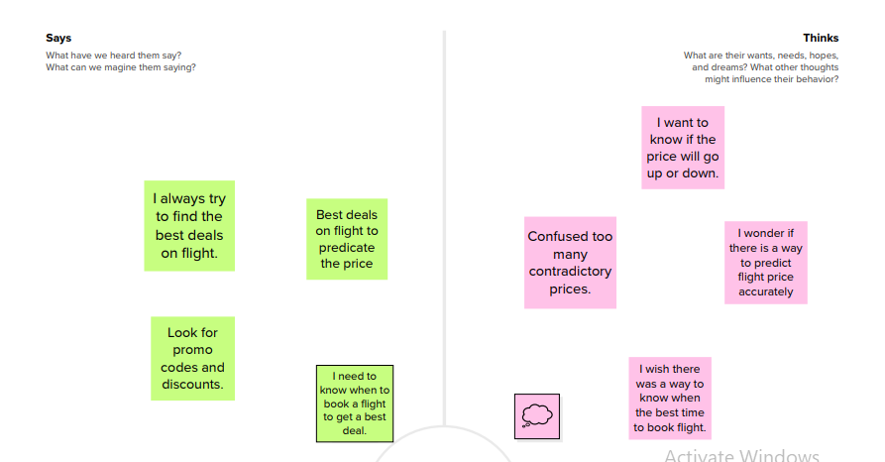

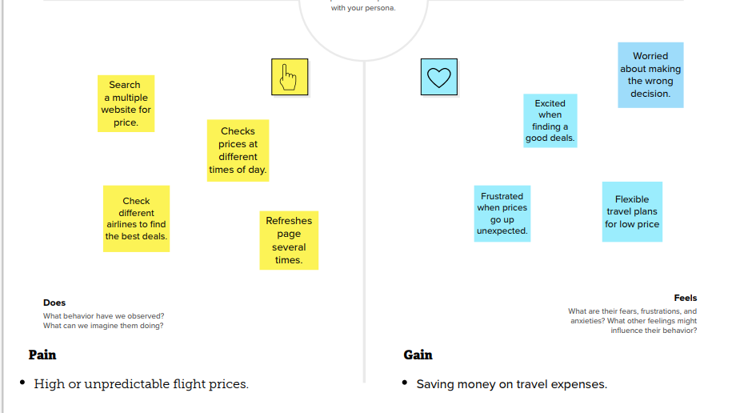

2.2 Ideation & Brainstorm Map

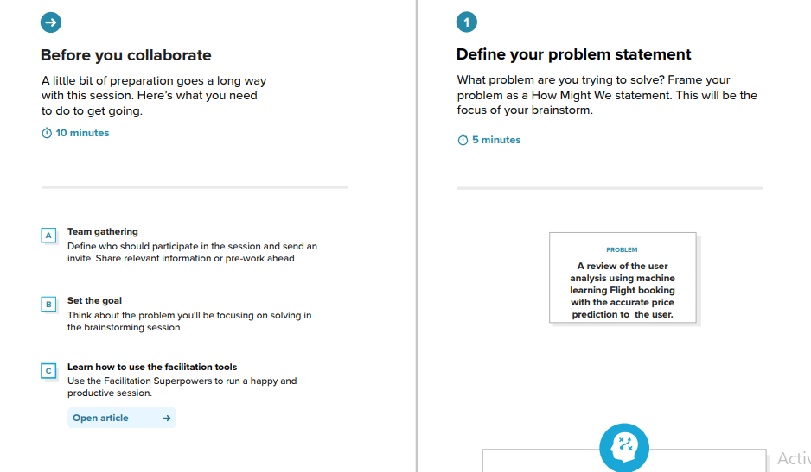

BRAINSTORM
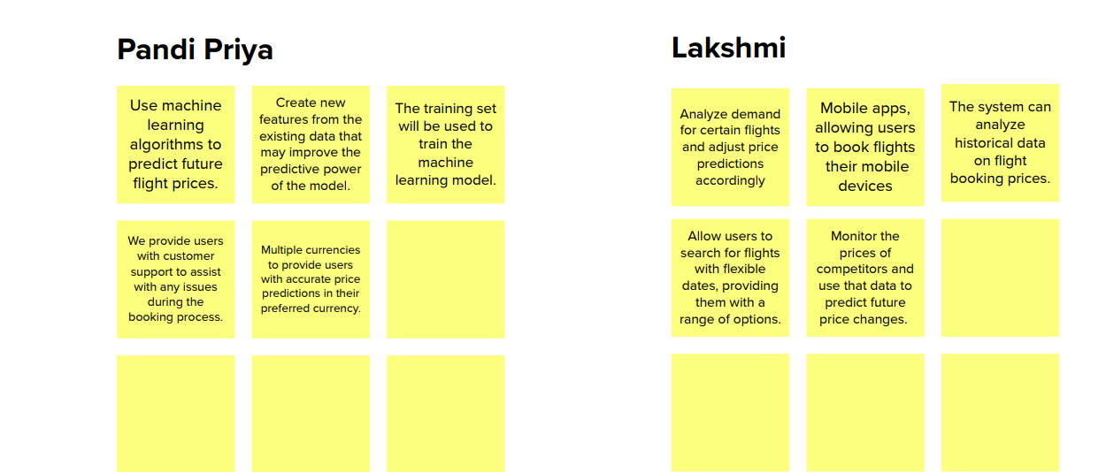

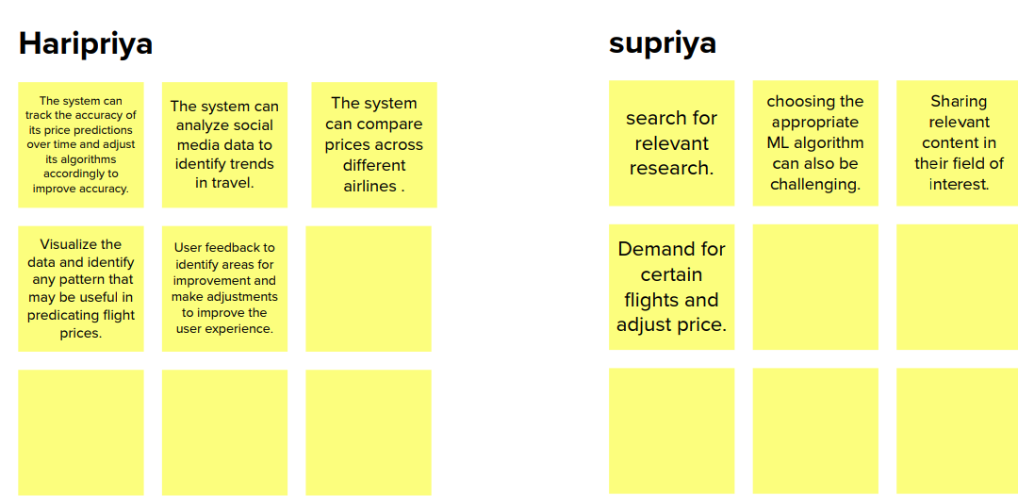

GROUP IDEAS:
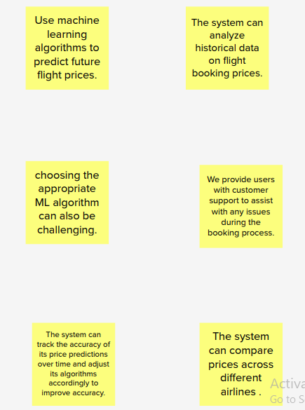

3.Result

Output
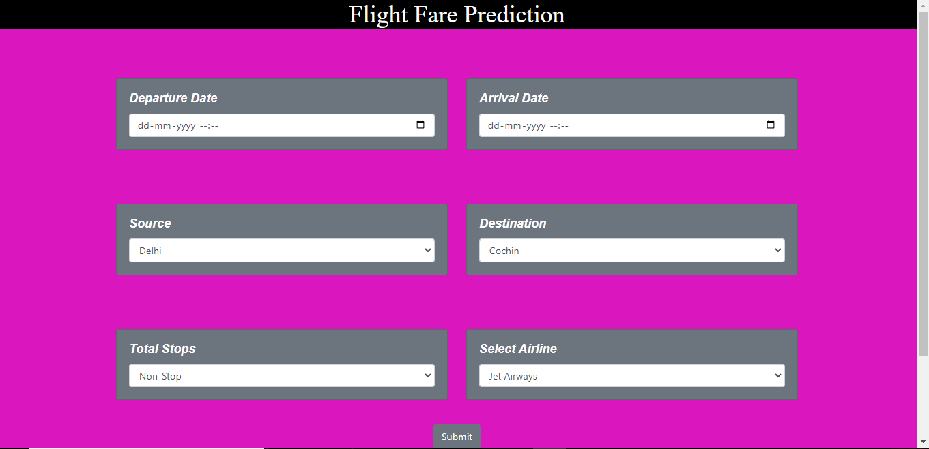

ADVANTAGE & DISADVANTAGE
Advantages :
Accuracy: Machine learning algorithms are capable of analyzing a vast amount of data, including historical pricing trends, consumer behavior, and market demand. This makes them highly accurate in predicting flight prices.
Cost-saving: Machine learning can help you save money on flight bookings. By predicting the best time to book, travelers can get the best deal on flights and save a lot of money in the process.
Time-saving: Machine learning algorithms can automate the flight booking process, saving time for both travelers and travel agents.
Personalization: Machine learning algorithms can provide personalized flight recommendations based on a traveler's preferences and previous bookings.
Efficiency: Machine learning algorithms can process large volumes of data quickly and efficiently, making it possible to provide real-time flight pricing information.

Disadvantages :
Limited data: Machine learning algorithms are only as good as the data they are trained on. If there is limited historical data available for a particular route, the predictions may not be accurate.
Algorithmic Bias: Machine learning algorithms can be biased based on the data they are trained on, which can lead to unfair and discriminatory pricing.
Lack of Transparency: Machine learning algorithms can be difficult to understand and interpret, making it hard for consumers to know how prices are being calculated.
Overreliance on predictions: Travelers may become over-reliant on machine learning algorithms and miss out on deals that don't fit the predicted patterns.
Data Privacy Concerns: Machine learning algorithms require access to large amounts of data, which raises concerns about data privacy and security.

APPLICATION

Machine learning-based price prediction applications can be applied to the aviation industry for optimizing flight bookings. This solution can be applied in several areas, including:
Travel booking websites: Travel booking websites can use machine learning-based price prediction applications to offer customers the best deals on flights. By analyzing historical data and current trends, the application can suggest the best time to book a flight and the cheapest dates to travel.
Airlines: Airlines can use machine learning algorithms to predict demand for flights, optimize pricing, and adjust their inventory accordingly. By accurately predicting demand, airlines can avoid overbooking or underbooking flights, which can result in lost revenue or unhappy customers.
Travel agencies: Travel agencies can use machine learning-based price prediction applications to offer personalized travel packages to customers. The application can analyze customer data and preferences to suggest the best flights, hotels, and activities based on the customer's budget and interests.
Corporate travel management: Companies can use machine learning-based price prediction applications to optimize their travel budgets. The application can suggest the best times to book flights, the most cost-effective routes, and the best airlines to use based on the company's travel policy.
Overall, machine learning-based price prediction applications can be applied to any area of the travel industry where optimizing flight bookings can lead to improved customer satisfaction and increased revenue

CONCLUSION

Optimization of flight booking through machine learning price prediction can greatly benefit both airlines and customers by accurately predicting flight prices, reducing costs and increasing revenue for airlines, and enabling customers to make more informed purchasing decisions. Through the use of machine learning algorithms, such as regression and neural networks, it is possible to analyze historical data on flight prices and various other factors, such as time of day, day of the week, and seasonality, to predict future prices with a high degree of accuracy. This can help airlines optimize their pricing strategies and improve their revenue management, while also providing customers with more transparency and confidence when booking flights. Overall, the use of machine learning for flight price prediction has the potential to revolutionize the airline industry and create a more efficient and effective marketplace for all stakeholders involved.

FUTURE SCOPE

The future scope for optimizing flight booking through machine learning price prediction is quite promising, as there is a lot of room for improvement in the current state of the airline industry. Some potential areas of development include:
Improved accuracy: As machine learning algorithms continue to advance, the accuracy of price predictions is likely to improve. This will help travelers make more informed decisions about when to book their flights and could potentially save them money.
Personalization: Machine learning algorithms can be trained to understand individual preferences and behaviors, allowing airlines to offer personalized recommendations to each traveler. For example, the algorithm could suggest flights that are most likely to be of interest based on past booking behavior.
Dynamic pricing: Airlines could use machine learning algorithms to adjust prices in real-time based on supply and demand. This would allow them to optimize revenue and fill empty seats, while still offering competitive prices to consumers.
Fraud detection: Machine learning algorithms can also be used to detect and prevent fraudulent activity in the airline industry, such as fake bookings or credit card fraud. This could help airlines save money and protect consumers from scams.
The future of optimizing flight booking through machine learning price prediction is likely to be driven by advancements in technology and increased data availability. As algorithms become more accurate and personalized, and airlines continue to invest in data-driven strategies, travelers can expect to benefit from more competitive prices and a better overall booking experience.

8.APPENDIX

A.Source code
<html lang="en">

<head>
<meta charset="UTF-8">
<meta name="viewport" content="width=device-width, initial-scale=1.0">
<title>Flight Price Prediction</title>

<!-- BootStrap -->
<link rel="stylesheet" href="https://stackpath.bootstrapcdn.com/bootstrap/4.5.0/css/bootstrap.min.css"
integrity="sha384-9aIt2nRpC12Uk9gS9baDl411NQApFmC26EwAOH8WgZl5MYYxFfc+NcPb1dKGj7Sk" crossorigin="anonymous">

<!-- css -->
<link rel="stylesheet" href="static/css/styles.css">

<style>

.design {
color: white;
font-family: Arial, Helvetica, sans-serif;
font-style: italic;
font-weight: bold;
}

body{
background-color: rgb(218, 22, 191);
}

</style>

</head>

<body>

<!-- As a heading -->

<h1 align="center" style="font-family: algerian; background-color: black; color: white;"> Flight Fare Prediction </h1>

<br><br><br>

<div class="container" >

<form action="\predict" method="post">

<div class="row">
<div class="col-sm-6 ">
<div class="card text-white bg-secondary mb-3">
<div class="card-body">
<h5 class="card-title design" >Departure Date</h5>
<!-- Departure -->
<input type="datetime-local" name="Dep_Time" id="Dep_Time" required="required" class="form-control">
</div>
</div>
</div>
<br>
<br>
<br>
<div class="col-sm-6">
<div class="card text-white bg-secondary mb-3">
<div class="card-body">
<h5 class="card-title design">Arrival Date</h5>
<!-- Arrival -->
<input type="datetime-local" name="Arrival_Time" id="Arrival_Time" required="required" class="form-control">
</div>
</div>
</div>
</div>

<br>
<br>
<br>

<div class="row">
<div class="col-sm-6">
<div class="card text-white bg-secondary mb-3">
<div class="card-body">
<!-- Source -->
<h5 class="card-title design">Source</h5>
<select name="Source" id="Source" required="required" class="form-control">
<option value="Delhi">Delhi</option>
<option value="Kolkata">Kolkata</option>
<option value="Mumbai">Mumbai</option>
<option value="Chennai">Chennai</option>
</select>
</div>
</div>
</div>
<div class="col-sm-6">
<div class="card text-white bg-secondary mb-3">
<div class="card-body">
<h5 class="card-title design">Destination</h5>
<!-- Destination -->
<select name="Destination" id="Destination" required="required" class="form-control">
<option value="Cochin">Cochin</option>
<option value="Delhi">Delhi</option>
<option value="New Delhi">New Delhi</option>
<option value="Hyderabad">Hyderabad</option>
<option value="Kolkata">Kolkata</option>
</select>
</div>
</div>
</div>
</div>

<br>
<br>
<br>

<div class="row">
<div class="col-sm-6">
<div class="card text-white bg-secondary mb-3">
<div class="card-body">
<h5 class="card-title design">Total Stops</h5>
<!-- Total Stops -->
<select name="stops" required="required" class="form-control">
<option value="0">Non-Stop</option>
<option value="1">1</option>
<option value="2">2</option>
<option value="3">3</option>
<option value="4">4</option>
</select>
</div>
</div>
</div>
<div class="col-sm-6">
<div class="card text-white bg-secondary mb-3">
<div class="card-body">
<h5 class="card-title design">Select Airline</h5>
<!-- Airline -->
<select name="airline" id="airline" required="required" class="form-control">
<option value="Jet Airways">Jet Airways</option>
<option value="IndiGo">IndiGo</option>
<option value="Air India">Air India</option>
<option value="Multiple carriers">Multiple carriers</option>
<option value="SpiceJet">SpiceJet</option>
<option value="Vistara">Vistara</option>
<option value="Air Asia">Air Asia</option>
<option value="GoAir">GoAir</option>
<option value="Multiple carriers Premium economy">Multiple carriers Premium economy
</option>
<option value="Jet Airways Business">Jet Airways Business</option>
<option value="Vistara Premium economy">Vistara Premium economy</option>
<option value="Trujet">Trujet</option>
</select>
</div>
</div>
</div>
</div>

<br>
<!-- Submit -->
<center> <input type="submit" value="Submit" class="btn btn-secondary"></center>
</form>

<br>
<center> <h3>{{ prediction_text }}</h3>

<br>
<br>
<p>©2020 Jatin Sadhwani</p> </center>

</div>

<!-- JavaScript -->
<script src="https://code.jquery.com/jquery-3.5.1.slim.min.js"
integrity="sha384-DfXdz2htPH0lsSSs5nCTpuj/zy4C+OGpamoFVy38MVBnE+IbbVYUew+OrCXaRkfj"
crossorigin="anonymous"></script>
<script src="https://cdn.jsdelivr.net/npm/popper.js@1.16.0/dist/umd/popper.min.js"
integrity="sha384-Q6E9RHvbIyZFJoft+2mJbHaEWldlvI9IOYy5n3zV9zzTtmI3UksdQRVvoxMfooAo"
crossorigin="anonymous"></script>
<script src="https://stackpath.bootstrapcdn.com/bootstrap/4.5.0/js/bootstrap.min.js"
integrity="sha384-OgVRvuATP1z7JjHLkuOU7Xw704+h835Lr+6QL9UvYjZE3Ipu6Tp75j7Bh/kR0JKI"
crossorigin="anonymous"></script>

</body>

</html>

